- \Operation\Embossing bottom\Embossing bottom
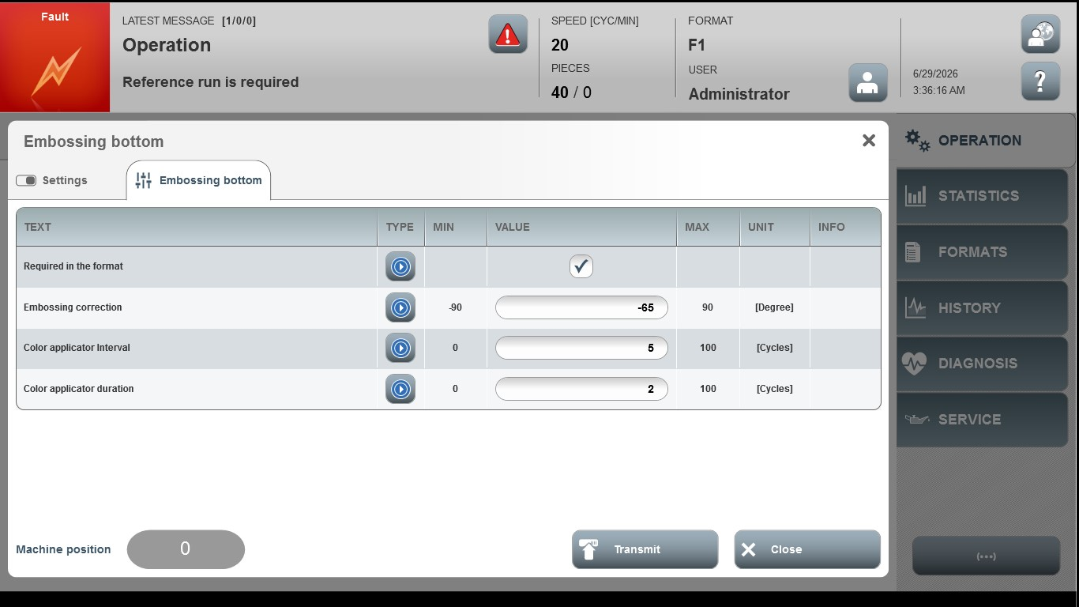
Acceptance criterion | Limits | Pass / Fail: Dev-No. | Date | Initials
Screen matches screenshot | N / A
Embossing correction | -90 … 90
Color applicator interval | 0 … 100
Color applicator duration | 0 … 100

